**Table of Contents**

**IoT Wearables for health monitoring of patients**1

Selected UN Goal2

Subsequent Sections2

**Background Study on Wearable Devices**3

**Key Problems with all of the chosen research papers and articles**5

**Potential Solution**5

**IoT component review**5

**Prototype Design and Architecture (Concept Model)**9

**Prototype Implementation**10

**Prototype Enhancement and Advancement**13

**Prototype Evaluation**13

**Conclusion**16

**References**17

**IoT Wearables for health monitoring of patients**

The major purpose of this report is to help people get an excellent wearable solution that monitors the health of the people who are suffering from diseases or ailments that require the checking of factors like heart rate, temperature, ECG (Electro Cardio Graph), EMG (Electro Muscular Graph) so that they can be cured and be healthy as soon as possible. We will be making an all-in-one wearable IoT device to send the health-related statistical data directly to the doctor over the cloud so he can examine the patient without being physically present near the patient and suggest proper medication and treatment. Moreover, if the doctor needs to monitor blood sugar, blood pressure, heart rate, muscular movement, etc. in real-time, then also this device will prove wonders to the doctors as well as the patients.

**Selected UN Goal**

For the rest of the report, the goal that has been taken into consideration is **Goal Number 3,** which is **Good Health and Well-Being** whose slogan goes like guaranteeing the health of all age groups is crucial for sustainable development.

**Subsequent Sections**

* **Background Study on Wearable Devices**
* **Key problems with all of the chosen research papers and articles**
* **A Potential Solution**
* **IoT component review**
* **Prototype Design and Architecture (Concept Model)**
* **Prototype Implementation**
* **Prototype Enhancement and Advancement**
* **Prototype Evaluation**
* **Conclusion**

The discussions that will be mainly covered in this report are the scope of IoT in healthcare (a.k.a. MIOT Medical Internet of Things), as well as the growth of the healthcare market in the future in the same industry. Till 2019, however, the research was being done in this field, and that too was mainly for the devices that would be used only by healthcare units or clinics themselves and not majorly and ubiquitously for the personal use of the people who wanted to monitor their health parameters on their own for their satisfaction along with sending and showing the data to their respective regular check-up physicians or doctors so that doctors can analyze past as well as present data to determine the patterns which might be leading to a harmful condition but with the speed, accuracy, and real-time connectivity, these conditions can be prevented and yes, the patients can lead a healthy lifestyle.

One thing to be noted here is that the collected data will be very large, so to get an upper hand over the analysis, at an intermediate step we can also add a Machine Learning algorithm that itself detects the patterns in the patients’ data and makes inferences based on the trained model. This might be seeming very tech-savvy and interesting here, but unless and until we train the model ample times and get an accuracy metric over which the doctors also agree, we cannot implement the model, as false or less accurate inferences made over the data will lead to a false diagnosis which is not desirable and unacceptable.

So, keeping the automatic analysis part apart, for now, the basic algorithm that we will be using is as follows:

* First, we will connect the IoT sensor to a suitable development board like (ESP-32 or ESP-8266).
* Next, we will configure the code uploaded into the IoT device such that the data is collected in a regular time interval, and if data is meant to be sent in real-time, then we will push the data to a real-time cloud service such as Microsoft Azure Cloud.
* Microsoft Azure Cloud already has features that support the incoming sensor data and it automatically rearranges the data in a statistical manner such as a graphical representation much similar to the representation which is shown in medical devices at hospitals, so the doctor can easily observe the data and proceed further.

**Background Study on Wearable Devices**

**Article Link** - <https://jwcn-eurasipjournals.springeropen.com/articles/10.1186/s13638-018-1308-x>

**Citation link** - <https://rdcu.be/cTObw>

Here, we will review the EURASIP Journal on Wireless Communications and Networking’s article about Wearable IOT real-time health monitoring systems.

This research paper dates back to 2018 and is developed by Jie Wan, Munassar A. A. H. Al-awlaqi, MingSong Li, Michael O’Grady, Xiang Gu, Jin Wang & Ning Cao.

This paper elaborates on the importance of Wearable IoT in the sector of healthcare and shows (not all steps, just an overview) how one can develop such IoT devices just at their home, more like a DIY project.

Collecting all of the health data with the help of sensors is one thing and managing is the other, so the researchers here have also demonstrated the use case of Mobile phones as a data collection unit, because mobile phones also have many inbuilt sensors, such as accelerometer which is responsible for alerting about the phenomena of fall detection if a patient falls and the mobile phone is in his pocket. As far as data management is considered, apps can be developed that can be used for analysis and extraction of inferences from the collected raw data, or on the other hand, the data can be sent entirely to the cloud, and the rest of the processing happens on the cloud itself.

**Drawbacks in this paper**

The drawbacks here are very normal but attentive that it is not comfortable for the patient to stick or attach sensors on his body all the time, for example, an ECG sensor can’t be stuck to the skin of a patient for a long time otherwise that can irritate the patient and technological challenges are developing a solution for providing long term power to the sensors and its circuitry so that there is friction less and non-delayed transmission of data, and lastly the there must be a seamless connection which must not be interrupted for successful data transmission.

**Business Challenges.**

Bringing down the cost along with increased efficiency of our device and making the device meet all the medical standards as well as competing with the existing healthcare solutions.

**Article Link** - <https://www.sciencedirect.com/science/article/pii/S1877050921001149>.

Publishers - [NicoSuranthaa](https://www.sciencedirect.com/science/article/pii/S1877050921001149#!)[PrabadinataAtmaja](https://www.sciencedirect.com/science/article/pii/S1877050921001149" \l "!)[b](https://www.sciencedirect.com/science/article/pii/S1877050921001149" \l "!)[David](https://www.sciencedirect.com/science/article/pii/S1877050921001149" \l "!)[c](https://www.sciencedirect.com/science/article/pii/S1877050921001149" \l "!)[MaulanaWicaksono](https://www.sciencedirect.com/science/article/pii/S1877050921001149" \l "!)[d](https://www.sciencedirect.com/science/article/pii/S1877050921001149" \l "!).

Computer Science Department, BINUS Graduate Program - Master of Computer Science, Bina Nusantara University, Jakarta, Indonesia, 11480.

This article from science direct to throws light on the use of wearable devices and the use of IoT devices for remote health monitoring of patients. The key thing which is a bit different from the previous paper in this one is that these researchers here have also pointed out an eminent application of remote IoT, that places, where hospitals are not present and if present, they are quite distant so the use of these personalized IoT gadgets can, of course, tell the doctors about any emergency and even smarter solutions, can predict such emergencies and proper first aid can be given to the monitored patient and hence helps in taking good care of their health.

This paper also depicts the usage of Smart Phones as an intermediate between the sensors and the cloud where Mobile and sensors are either connected with Bluetooth or Wi-Fi and Mobile is connected to the cloud via the internet.

**Future Work in this paper**

More work in this field requires the sensors to be running and compatible in every condition and not disturb the comfort of the user or patient of personalized devices.

**Article Link** - <https://www.scnsoft.com/healthcare/medical-devices/wearable>

This article here mainly discusses the market synopsis of the use and commerce of personalized healthcare IoT devices.

The wearable technology market in healthcare is estimated to be worth $16.2 billion, and it is projected to grow to $30.1 billion by 2026 at a CAGR (Compound Annual Growth Rate) of 13.2%.

Additionally, this article states that customers in the United States have shown a keen interest in having a wearable device for monitoring at least one health indicating factor as either temperature or heart rate, which are the most common of all.

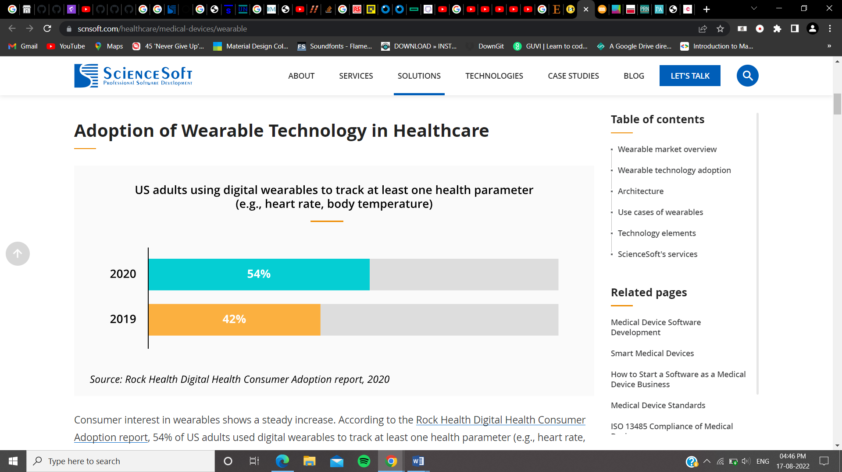

**Figure 1: The Percentage of customers that have increased in owning wearable devices for healthcare**

Science Soft, the company that released this paper, offers solutions for wearable medical monitoring equipment.

**Article link -** <https://www.spglobal.com/marketintelligence/en/news-insights/research/higher-consumer-awareness-of-health-monitoring-devices-may-expand-market>

This article also emphasizes the business logistics of wearable healthcare IoT devices instead of research in this field.

Generally, after COVID-19 pandemic, many users such as those in the report above have tended to have wearable health monitoring devices.

According to the survey done by this company, the customers who are significantly aware of owning a health monitoring device are investing in such devices much more. Since health is considered the first thing to be excellent in the human body, many of the youngsters responded to this survey that they want a healthcare monitoring device more than any other tech device because it helps in yielding better productivity and also leading a healthy life.

Therefore, around 70% of all consumers selected the blood pressure monitoring system they would like to own. Additionally, 30% of all respondents said that they owned blood oxygen monitoring devices.

The motto of including the above two articles is specifying the potential of the healthcare business, and this should be kept in mind that no matter whether it is a business, all organizations, companies, and this report are written to serve society and spread healthy vibrations everywhere.

**Article Link-**<https://www.researchgate.net/publication/327976264_IoT_Based_Wearable_Smart_Health_Monitoring_System>

Publishers - Mehmet Taştan, Manisa Celal Bayar University. Time – September, 2018.

In this article, the author has developed a health monitoring system with the help of IoT devices, namely, Arduino Pro Mini, Pulse Sensor, and a Bluetooth module. The Pulse sensor sends the data to Arduino Pro Mini and Arduino sends data to the Mobile, and the mobile uploads data to the cloud, and if the heart rate goes above a specific value then the user, doctor, or family member is notified via an alert.

However, this is a prototype only and not a full fledge solution.

**Key problems with all of these chosen research papers and articles**

The comfort of the patient while wearing these devices must be taken into consideration when analyzing these reports. For instance, if a smartwatch has a sensor to track heart rate and temperature, it is simple to incorporate these sensors and the user can be expected to wear the watch constantly. However, in order to access data like ECG, EMG, sleep patterns, blood sugar, and oxygen levels, sensors must be attached to the human body rather than just the wrist.

We will thus work to solve this issue by creating a wrist-worn device that has all of the aforementioned sensors, which would otherwise be very challenging to keep permanently attached to the patient's body.

**Potential Solution**

So, our solution here will focus on developing a wrist wearable watch or device which comprises as many as sensors possible to get the maximum number of health parameters. Additionally, we can also try to choose the best battery power supply for our devices to get rid of the hassle of charging the devices again and again.

**IoT Component Review**

**List of components to be used in our solution**

For starters and the proof of concept, we will only be using a heart rate monitoring sensor along with the development board called ESP-8266, which has Wi-Fi so that we can connect it directly to the internet and push the sensor data to Azure Cloud for further analysis and we will be writing all of the code in Arduino IDE.

* Breadboard

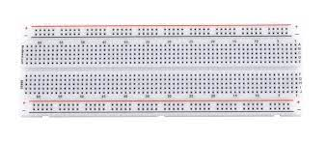

**Figure 2: Breadboard**

This is a breadboard, and its pin holes allow us to quickly mount our sensors and development board there to keep them firmly in place. Moreover, the connections of sensors, power supply, and dev board become easy and understandable when we use a breadboard. Here, however, we will discard the use of the breadboard, although, its usage is great for developing a prototype.

* ESP-8266

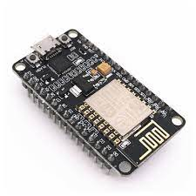

**Figure 3: NodeMCU or ESP-8266 Development Board**

This is a development board called ESP-8266 or NodeMCU (Node Micro-Controller Unit). It has **128KB** of RAM and a storage of **4MB.** It has a built-in Wi-Fi module that would help us to connect to the internet and our Azure server.

* Jumper Wires

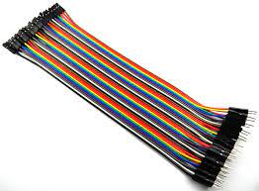

**Figure 4: Jumper Wires**

These are the connecting wires known as jumper wires, there are three types of jumper wires known as Male-to-Female, Male-to-Male, and Female-to-Female jumper wires. They are used to connect sensors and other equipment to the development board.

* Heart Rate Sensor

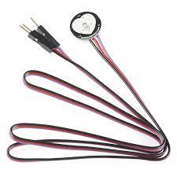

**Figure 5: Pulse Sensor or Heart Rate Sensor**

This is the pulse sensor that calculates the heart rate of the user.

* USB cable

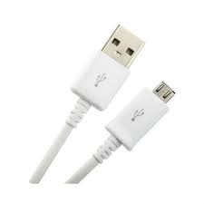

**Figure 6: USB cable**

This is the USB cable that would help us in connecting the Development board to the computer for programming the development board to perform a specific task.

* Arduino IDE

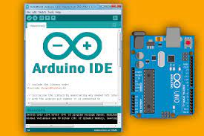

**Figure 7: Arduino IDE**

This is the software called **Arduino IDE** that we would be using to program our NodeMCU.

**Prototype Design and Architecture (Conceptual Model)**

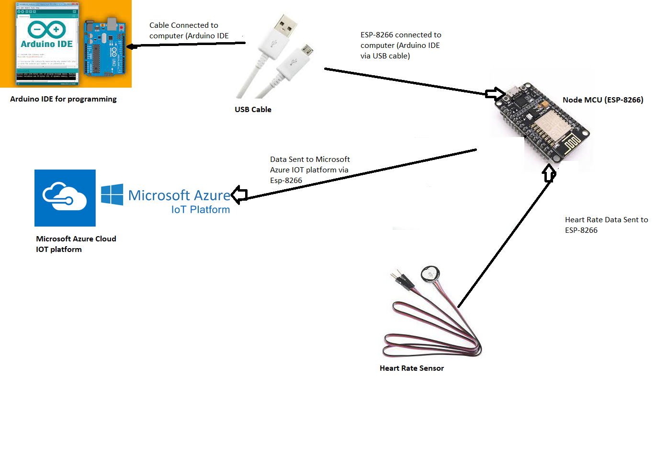

**Figure 8: Architectural Diagram of Our Prototype**

The figure above shows the Design and Architecture of our prototype model. How every component is connected to collect health parameter data and notifying the doctors or relatives if some alarming condition occurs so that further complications can be prevented.

**Prototype Implementation**

Since this project is proof of concept only, what we would be doing here is first connecting the heart-rate sensor to the NodeMCU and then uploading the code to NodeMCU that performs the heart-beat reading function and pushes the heartbeat in real-time to the Microsoft Azure server where device template is already setup to receive and plot the data.

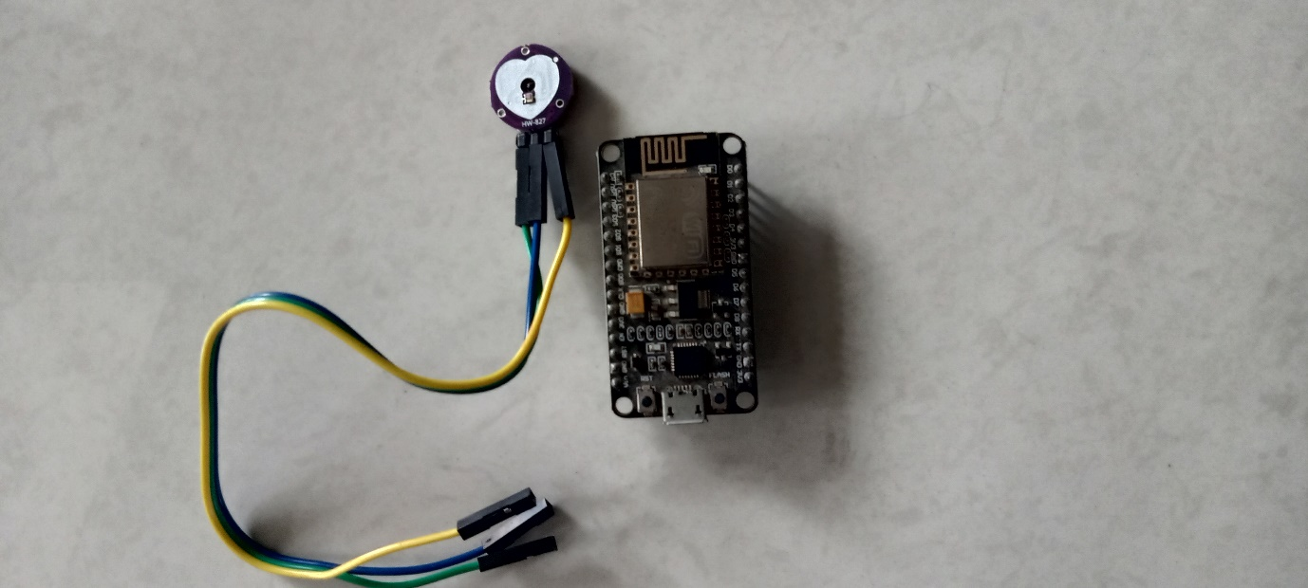

**Figure 9: Pulse Sensor and NodeMCU**

These are the two major components required to build this project, ESP8266 and Pulse Sensor.

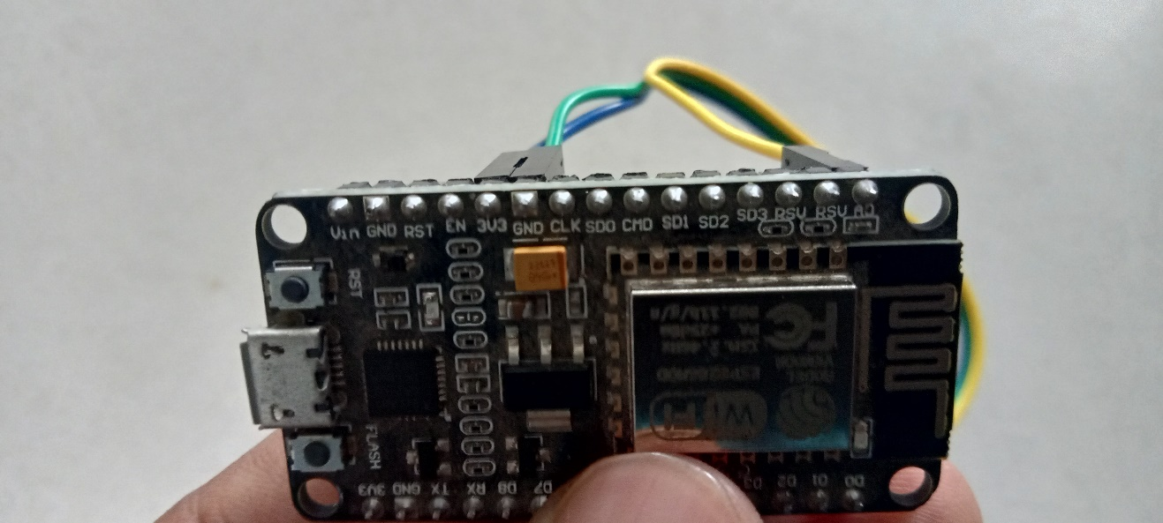

**Figure 10: Pulse Sensor’s Pins connected to NodeMCU**

As you can see, here, the sensor’s +ve pin is connected to 3v3 (3v output supply of ESP8266) and the -ve pin is attached to GND or ground pin.

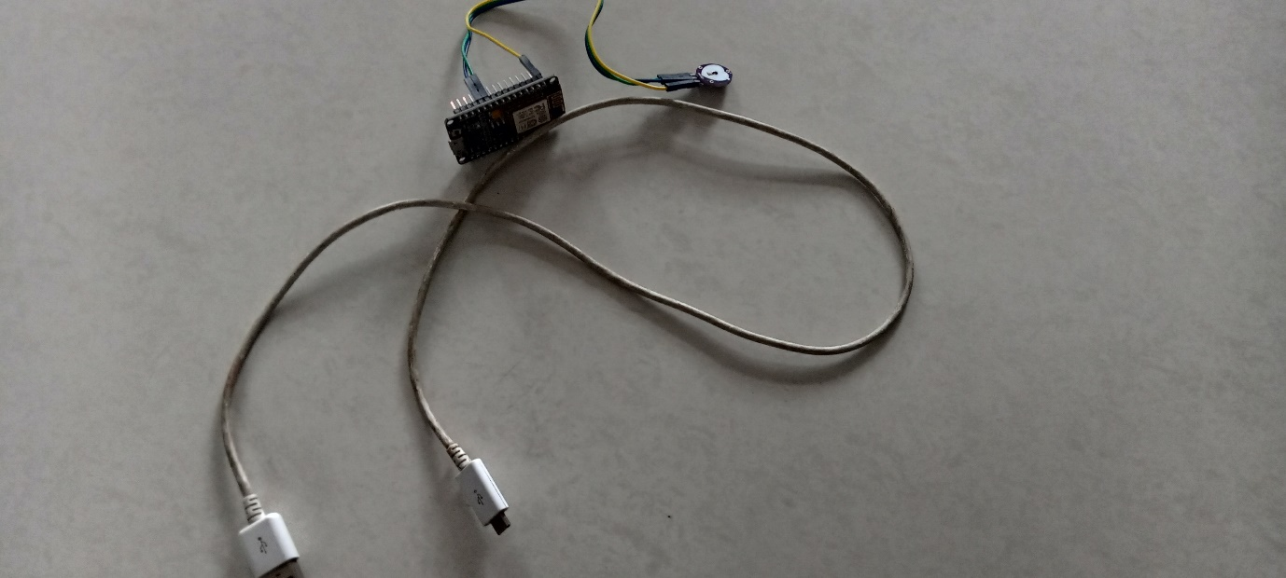

**Figure 11: USB Cable with Connected circuit**

This is our simple circuitry with the USB cable that would allow us to connect ESP8266 or NodeMCU to the computer for programming it.

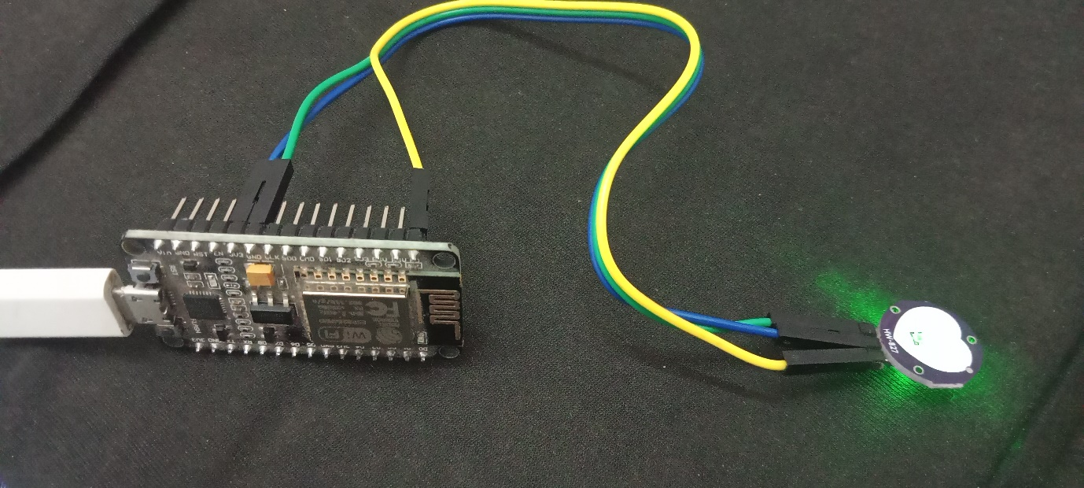

**Figure 12: NodeMCU connected to Computer**

As soon as we connect the ESP8266 to the computer we can observe a green light coming out from the sensor that tells us that our connection was right and now it's time to upload the code to the dev board.

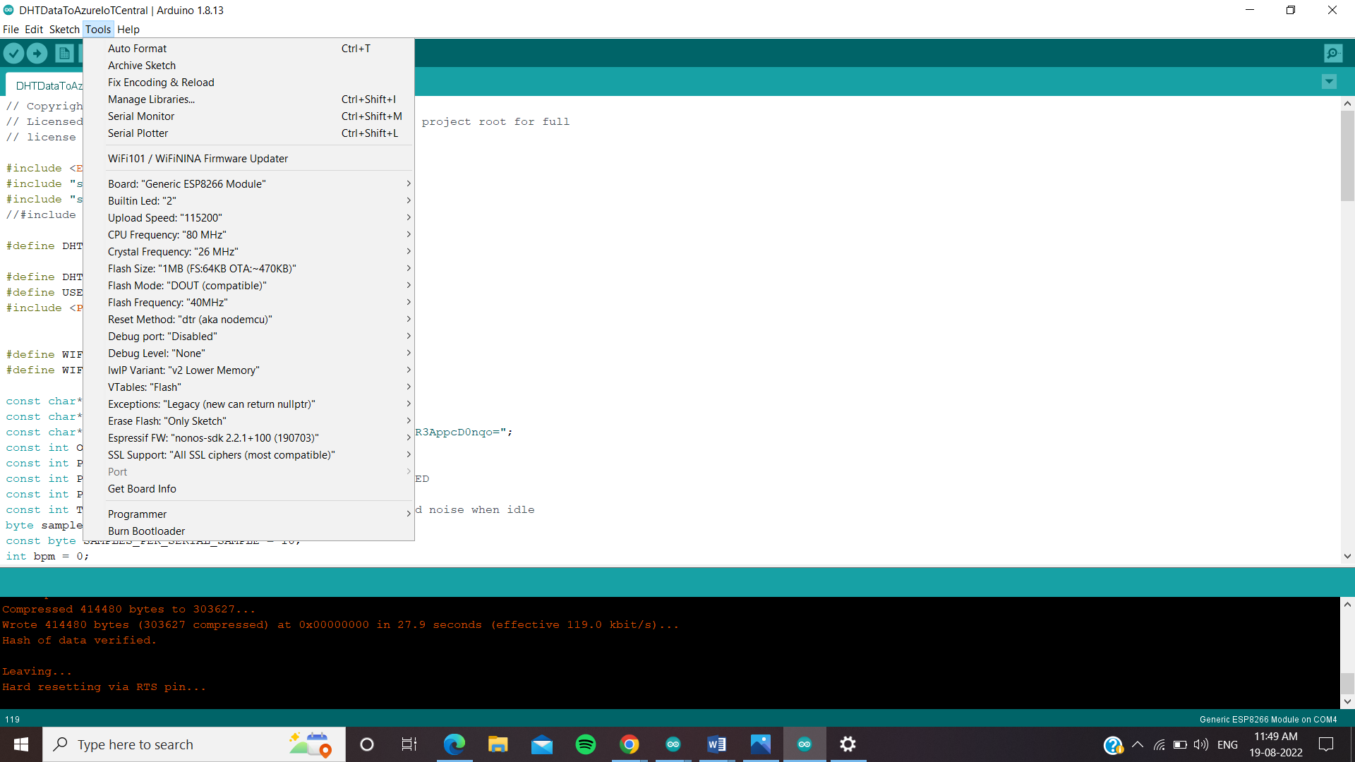

**Figure 13: Arduino IDE in which “Generic ESP8266 Module” is selected**

Here, we have chosen the correct Board called “Generic ESP8266 Module” along with port “com4” (the port name may differ in different computers and with different ports). The code has been taken from the GitHub repository - <https://github.com/adesolasamuel/NodeMCUtoAzureIoTCentral> and it has been modified to work with the pulse sensor. The original code written here is for the DHT Humidity and Temperature sensor.

Also, one thing to note here is, that in our Arduino IDE we have downloaded the 2.7.4 version of ESP8266 because that one was compatible with this code

**Prototype Advancement and Enhancement**

Since the size and apparatus of our current model are not the ones that can be easily standardized to make its duplicates and bring them down directly into the hands of consumers in the market, we will be using it, obviously, as a prototype. We can reduce the cost to a very reasonable figure so that it is affordable to the customers and as well as generates enough revenue to fuel back the manufacturing process and other needs.

Along with this, several sensors can be added the ones that are small in size and that can be integrated and implemented as custom circuitry that leads to best space management and space minimization, and resource optimization.

**Prototype Evaluation**

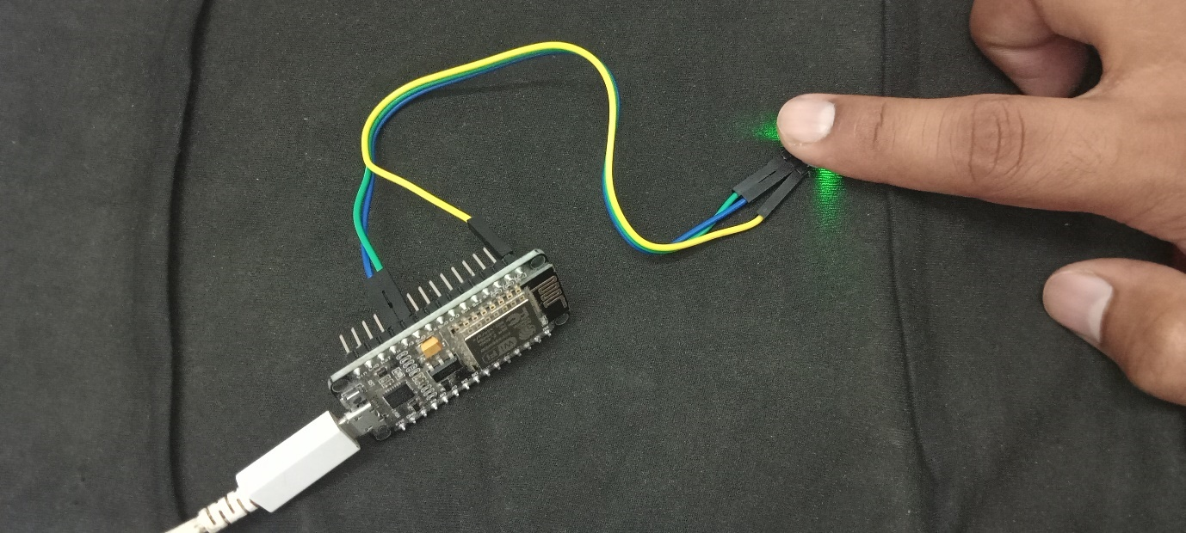

**Figure 14: Touching the sensor to give readings**

Now, after the code has been successfully uploaded when we touch the pulse rate sensor, we can see the readings in the serial monitor of our Arduino IDE.

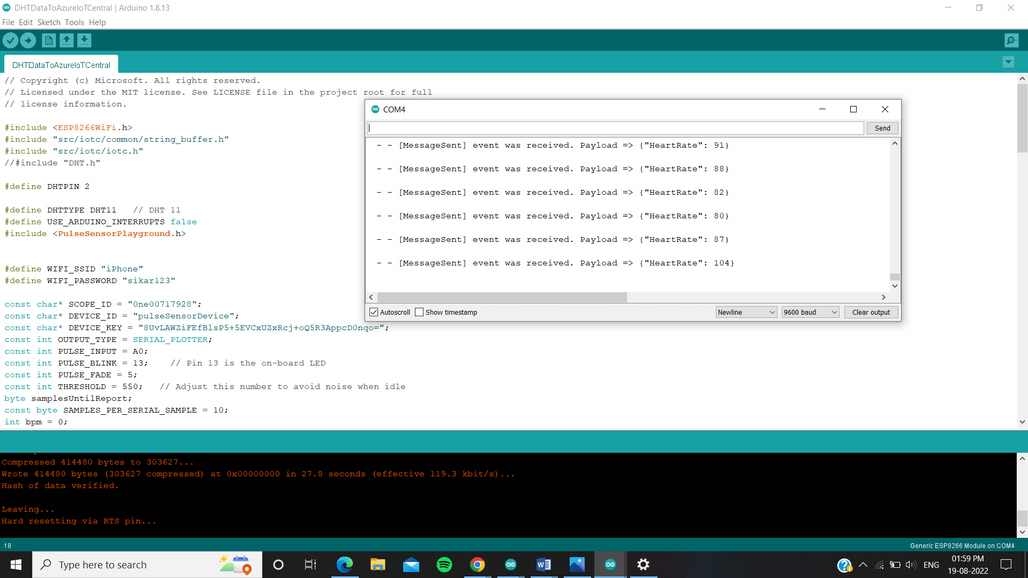

**Figure 15: The readings are being sent to Microsoft Azure’s IoT Central Application**

In the COM4 window, the heart rate is measured and directly sent to our Azure IoT Central Application.

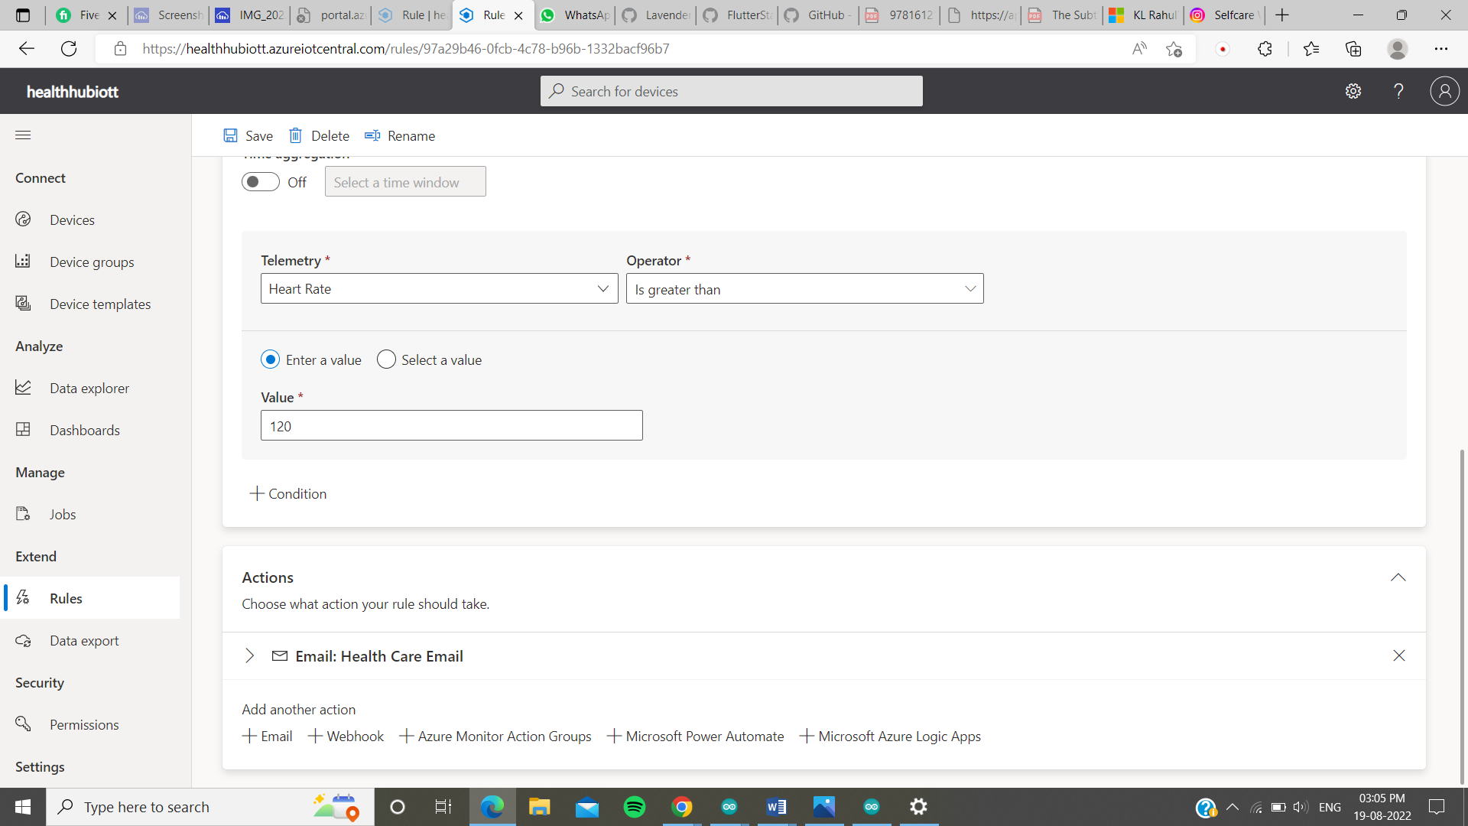

**Figure 16: Heart rate exceeds 120BPM alert trigger**

Azure itself provides an alert condition, that when the given value of any parameter is in relation (either greater than or smaller than etc.) with the current value, then a certain action like an Email alert can be performed, here in our case the email is sent when the heartbeat exceeds 120BPM.

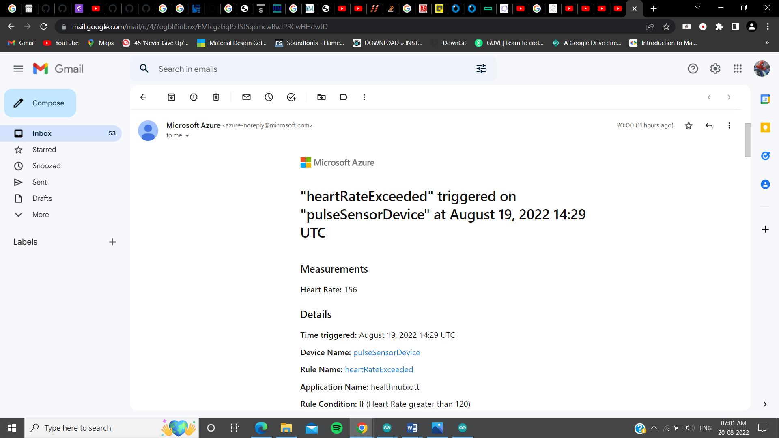

**Figure 17: Heart rate exceeds 120BPM alert trigger email on provided account.**

A thing to keep in mind here is that the email would only be sent to those people who have been added as any role to our Azure application.

**Conclusion**

This project has strictly been made with the words kept in mind – “proof of concept”. However, it may seem that project like this is already out there, but only a countable number of devices or almost none provides the feature of real-time data transmission to the doctor. One thing to notice here is, that it is a baby step towards building a better device that serves the people and healthcare industry with its technological features. At any stage, for now, we can assume and for sure know that there is always room for improvement. Future work on this project can be done to use the human body as a source to power up the device.

Moreover, yes, there can be some security issues, because the Internet of Things network is easily hackable, which means anyone who is either in the local network of ESP8266 can perform attacks and gain access to the data that is being transmitted. However, no one would want to steal or sniff the medical data of any person, but it is a security issue that must be addressed.

**References**

<https://jwcn-eurasipjournals.springeropen.com/articles/10.1186/s13638-018-1308-x>

<https://rdcu.be/cTObw>

<https://www.sciencedirect.com/science/article/pii/S1877050921001149>

<https://www.scnsoft.com/healthcare/medical-devices/wearable>

<https://www.spglobal.com/marketintelligence/en/news-insights/research/higher-consumer-awareness-of-health-monitoring-devices-may-expand-market>

<https://www.researchgate.net/publication/327976264_IoT_Based_Wearable_Smart_Health_Monitoring_System>

<https://how2electronics.com/getting-started-with-azure-iot-central-using-esp8266/>